

|  |  |
| --- | --- |
| **STUDENT NAME** | **Abdullah Muhammad Ibrahim** |
| **STUDENT ID** | **SP20-BSCS-0027** |
| **SECTION** | **AM** |
| **ASSIGNMENT NO.** | **04** |
| **DUE DATE** | **Nov 6, 11:59 PM** |
| **SUBMITTED ON** | **Nov 6, 2020** |

**Question 1/Task 1:**

**Create a class named ‘Student; having two variables ‘name’ and ‘roll_no’**

**respectively. Assign the value of roll_no as ‘101’ and that of name as Ahmed by**

**creating an object of the class Student. Print the values in the main/test/driver class.**

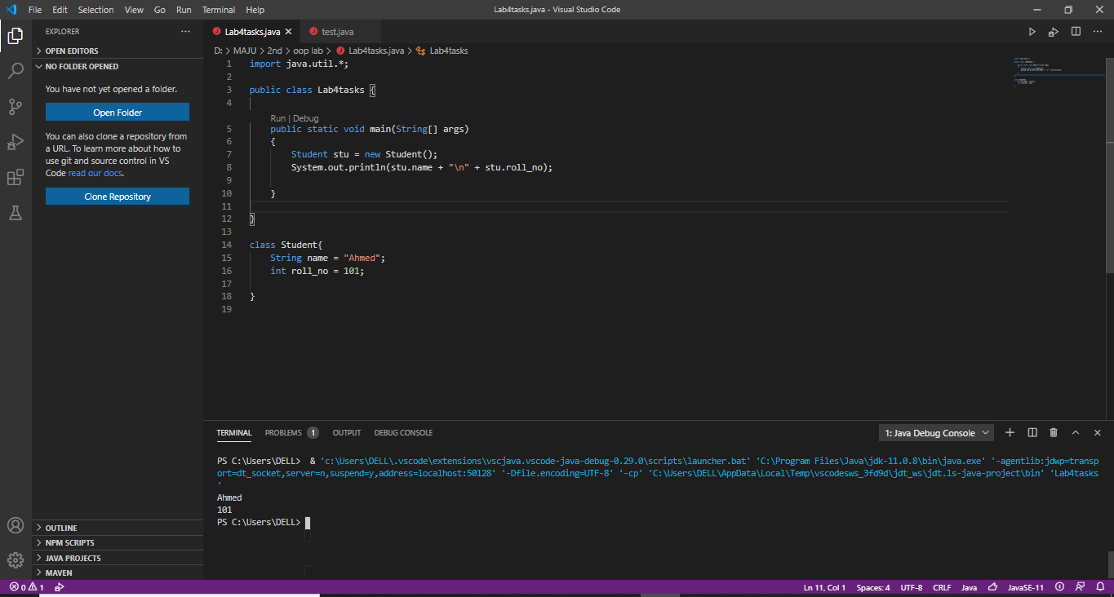

**Question 2/Task 2:**

**Modify the above program that assigns and print the roll number, age and address of**

**two students having names Ali and Ahad respectively by creating two objects of**

**class ‘Student’.**

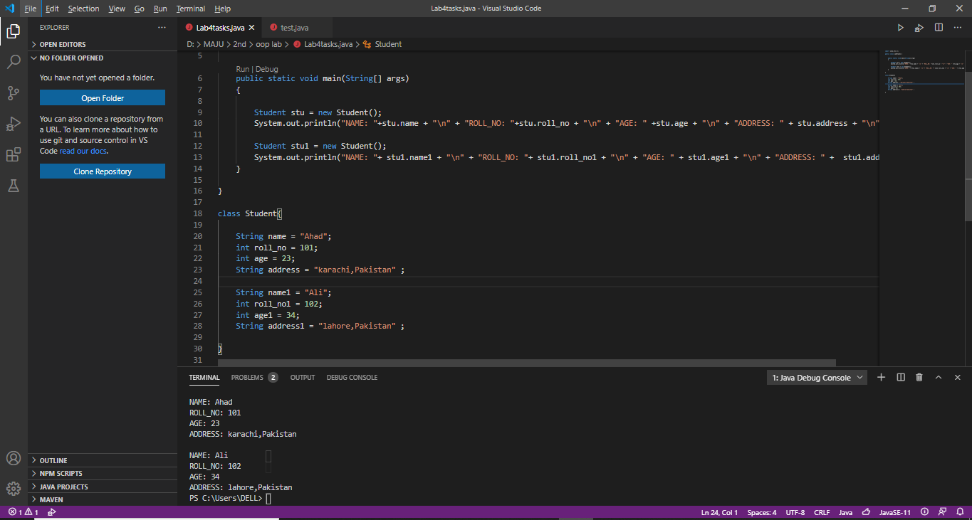

**Question 3/Task 3:**

Write a program to print the area of a rectangle by creating a class named ‘Area’

having two methods. First method named as ‘setValues ()’ that takes length and

breadth of rectangle as parameters and the second method named as ‘getArea ()’ that

returns the area of the rectangle. Length and breadth of rectangle should be entered

through keyboard. 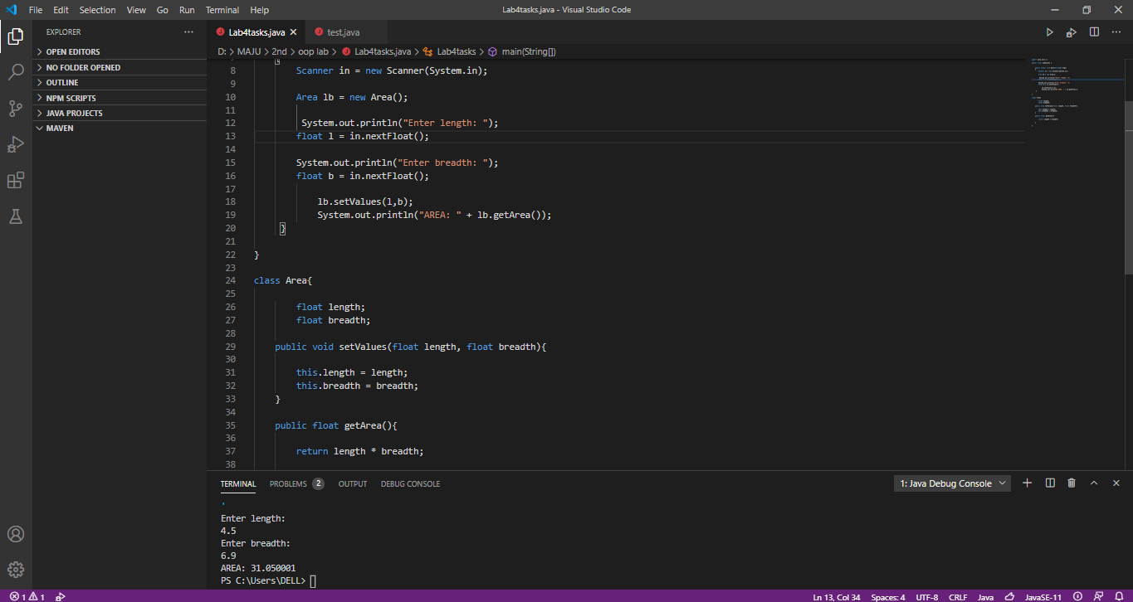

**Question 4/Task 4:**

Create a class named ‘Average’ having a method calculateAverage () that calculates

the average of three numbers entered by user and print the average.

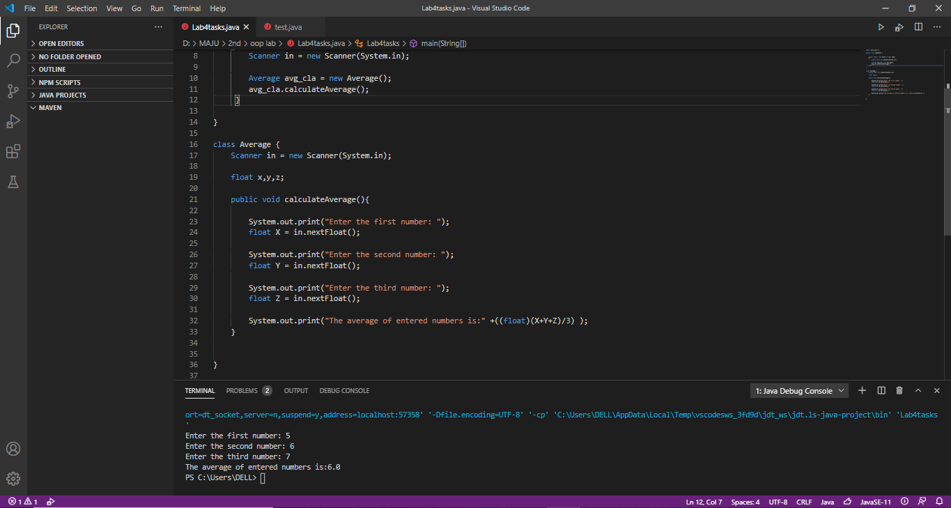

**Question 5/Task 5:**

Create a class named ‘Employee’ having the following two instance methods.

a. getInfo()

b. printInfo()

The getInfo() method takes the information about employee’s name, year of joining,

salary and city as parameter.

The printInfo() method prints all the information.

Your main/driver/test class should print information of three employees. The output

should be as follows:

Name        Year of joining     Salary     City

Ahmed            1998                 85000 Karachi

Ali                 2002                95500 Islamabad

Sara                 1991                 80000 Hyderabad

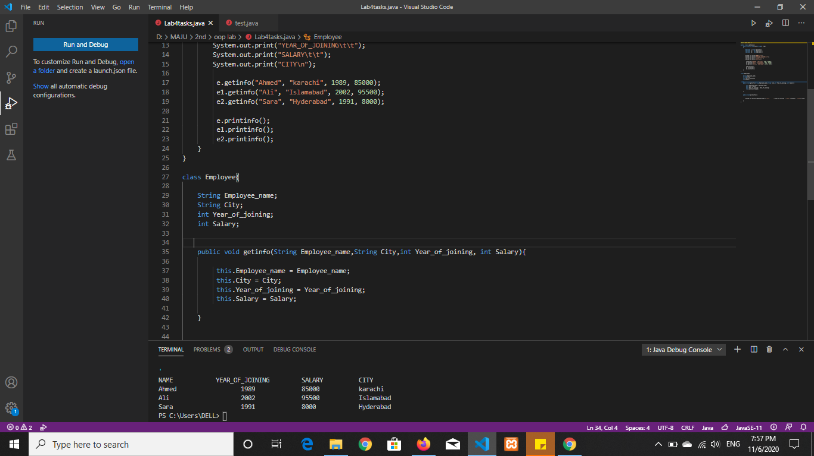

**Question 6/Task 6:**

Write a java program that creates an ‘Employee’ class having the following methods:

• ‘getInfo ()’ this method takes the salary, number of hours of work per day of

employee as parameter.

• ‘addBonus ()’ this method adds $15 to the salary of the employee if it is less than

$600.

• ‘addWork ()’ this method adds $10 to the salary of employee if the number of

hours of work per day is more than 8 hours.

Print the final salary of the employee.

